

**Faculty of computers and artificial intelligence**

**Cairo University**

**Final project**

**Course title: Fundamentals of Management_General_2021 second semester**

**Warriors convert**

**Instructor: Dr. Doaa Saleh**

|  |  |
| --- | --- |
| Team members | |
| **Name** | **ID** |
| **Abdalla Mohamed Shabaan** | **20190307** |
| **Kerolos Romany Sabry** | **20190394** |
| **Hady Saad Eldein** | **20190606** |
| **Ahmed Khalaf Mohamed** | **20190028** |
| **Ezzeldin Magdy Mokhtar** | **20190331** |

**LOGO**

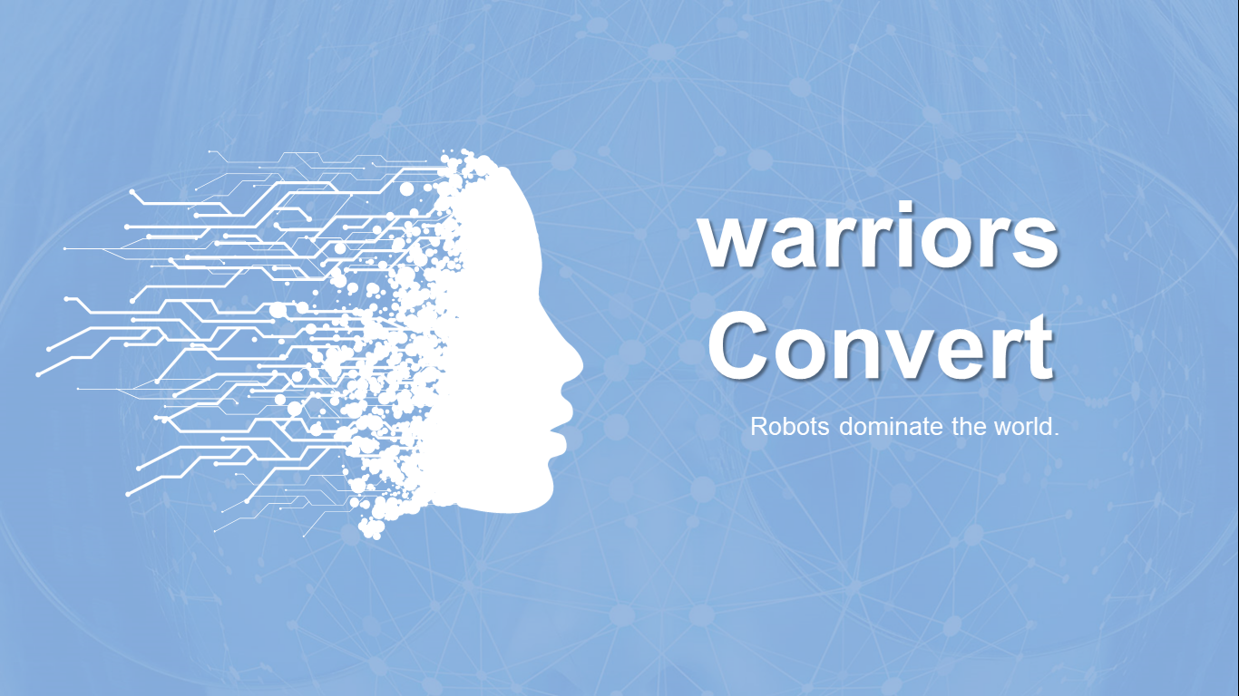

**Table of Contents**

**Introduction**............................................................................................................................................... 4

**Advantages of the robots**...........................................................................................................................4

**Disadvantages of the robots**…………...........................................................................................................8

**Types of robots**........................................................................................................................................10

**1. Planning**...............................................................................................................................................11

**1.1. Vision**....................................................................................................................................11

**1.2. Mission**.................................................................................................................................11

**1.3. Strategy**................................................................................................................................12

**1.4. Values**...................................................................................................................................13

**2. Organizing**............................................................................................................................................14

**2.1. Co-ordination between authority and responsiblitiy**.........................................................14

**3. Influencing** ..........................................................................................................................................14

**4. Controlling**....................................................................................................................…………………….15

**4.1. Standard Performance**........................................................................................................15

**4.2. Actual Performance**.............................................................................................................15

**4.3. Error**.....................................................................................................................................15

**4.3.1. Software error**.....................................................................................................15

**4.3.2. Connection error**.................................................................................................16

**4.3.3. Technical error**....................................................................................................16

**Introduction:**

Now Robots are widely spread, precisely in the developed countries like japan and china and the result of this spread people lose a lot of jobs.

Actually robots make life easier than it was before because of the power of robots and the speed of these things, People use them in the dangerous and boring jobs. So robots are spread in the factories like cars factories, also people use them in the exploratory space trips also people used them in the hard work jobs that will make them suffer; everyday they used to find a way to make use of robots and reduce manual labor so robots will dominate the world through next years.

This project is to make robots to help armies in wars; they will be armed with all possible weapons, they will be programmed to use these weapons well and when to use them, this project will help to reduce human losses, by these robots it will be the guerrilla soldiers who can attack the enemy’s camp.

**Advantages of the robots:**

* They can do what human does easily, they also faster than human also they can do what human can’t.
* They can do our tasks in a short time without being bored, or taking rest, they never get sick, and the best one that they never complain.
* Can reach places where humans cannot:

Robots can reach the places where it humans cannot breathe or survive. They can provide you with information that is hard for humans to acquire. The best thing is that you do not need to pay the salary for robots or serve them with delicious food to keep them happy. All they need is charging. No human-like to do monotonous tasks. If you do it repeatedly, you will get bored, but robots will not complain about getting bored.

* Work without human interference:

You do not need to wake up the robot to carry out its tasks. Everything is done automatically just by passing a few commands to it. This will awaken even the whole world is sleeping. You can use robots for entertainment and get out of depression and also carry out various household and office tasks. Also, if you want to learn about underwater, you can send them into the deep sea to gather information or clicks of the deep sea.

* Tolerate a hostile environment:

Robots can survive in the interplanetary space. The robots are made in such a way that their physical state and performance remain the same even when they enter the other planets. These are perfect for doing the jobs of humans done with consistency and accuracy. Undeniably, a single robot is equal to 100 human beings, which is one of the advantages of robotics. They can take up many responsibilities and can also manage themselves without human intervention.

* Do Repetitive and dangerous tasks:

I often complain of doing the monotonous job. However, with the advent of robotics technology, I am delighted that takes the repetitive and time-consuming tasks from the shoulders of humans and does it for them. In addition to simple yet boring jobs, they can also do hazardous tasks. Also, they have the ability to set the speed and time of doing the tasks. The best thing is that they can act as a faster pace without getting affected by the factors which humans do.

* Work without break:

Can you work continuously for two days without taking a break? I personally “No” Humans go nuts and their brains stop working when they work without a break and sleep. However, robots can work without sleep and break. You can employ robots in places where it is risky for humans to handle jobs. They can work continuously for months together without a break, maintenance and are considered to be more productive than people.

* Carry Medical surgeries:

Do not get amazed to see robots in hospitals and doing surgeries to patients in the coming years. They behave like humans. There are a few robots which are kept in the entrance of hospitals to shake hands with patients and calculate their blood pressure, weight and other parameters. They are also performing surgeries in a few hospitals more precisely.

* Safety:

Safety is the most obvious advantage of utilizing robotics. Heavy machinery, machinery that runs at hot temperature, and sharp objects can easily injure a human being. By delegating dangerous tasks to a robot, you’re more likely to look at a repair bill than a serious medical bill or a lawsuit. Employees who work dangerous jobs will be thankful that robots can remove some of the risks.

* Speed:

Robots don’t get distracted or need to take breaks. They don’t request vacation time or ask to leave an hour early. A robot will never feel stressed out and start running slower. They also don’t need to be invited to employee meetings or training session. Robots can work all the time, and this speeds up production. They keep your employees from having to overwork themselves to meet high pressure deadlines or seemingly impossible standards.

* Consistency:

Robots never need to divide their attention between a multitude of things. Their work is never contingent on the work of other people. They won’t have unexpected emergencies, and they won’t need to be relocated to complete a different time sensitive task. They’re always there, and they’re doing what they’re supposed to do. Automation is typically far more reliable than human labor.

* Perfection:

Robots will always deliver quality. Since they’re programmed for precise, repetitive motion, they’re less likely to make mistakes. In some ways, robots are simultaneously an employee and a quality control system. A lack of quirks and preferences, combined with the eliminated possibility of human error, will create a predictably perfect product every time.

* Happier Employees:

Since robots are often assigned to perform tasks that people don’t particularly enjoy, like menial work, repetitive motion, or dangerous jobs, your employees are more likely to be happy. They’ll be focusing on more engaging work that’s less likely to grind down their nerves. They might want to take advantage of additional educational opportunities, utilize your employee wellness program, or participate in an innovative workplace project. They’ll be happy to let the robots do the work that leaves them feeling burned out.

* Job Creation:

Robots don’t take jobs away. They merely change the jobs that exist. Robots need people for monitoring and supervision. The more robots we need, the more people we’ll need to build those robots. By training your employees to work with robots, you’re giving them a reason to stay motivated in their position with your company. They’ll be there for the advancements and they’ll have the unique opportunity to develop a new set of tech or engineering related skills.

* Productivity:

Robots can’t do everything. Some jobs absolutely need to be completed by a human. If your human employees aren’t caught up doing the things that could have easily be left for robots, they’ll be available and productive. They can talk to customers, answer emails and social media comments, help with branding and marketing, and sell products. You’ll be amazed at how much they can accomplish when the grunt work isn’t weighing them down.

**Disadvantage of these robots:**

* People will lose jobs in factories.
* Reducing manual labor will reduce human’s fitness, power and effort.
* Supply power continuously and cost higher:

This is one of the disadvantages of robotics. Robots consume a lot of power to function. Many daily wage workers would lose their jobs, which are actually the bread and butter of their families. Robots need to be maintained continuously to keep them in good condition. You would need to invest a huge amount of money to buy robots. On top of this, to develop software to make it function as per your needs would cost whopping.

* Increase unemployment:

I see many youngsters without jobs. If robotics comes into force, then many skillful workers would also lose their jobs and would be on roads, which is one of the disadvantages of robotics. Robotics is certainly going to replace workers in factories. People either have to look for other jobs or to be trained in how to work with robots. If robotics starts to replace humans, then definitely the unemployment rate across the globe increases.

* Cost a fortune for maintenance and repair:

You need to continuously maintain robots to keep them in top-notch condition to retain their performance. The programs incorporated in robots should be updated as per requirements. In the case of outages, it cost you a fortune to get it repaired. Moreover, the time it takes to restore lost data and cost would be high.

* Not easy to retrieve data:

Robots are good at storing huge chunks of data in them, but when lost is hard to retrieve. It is not as powerful as the human brain. Though they can carry out monotonous tasks, they cannot get better to best as humans do over time, which is one of the disadvantages of robotics.

* No emotions:

Robots do not have any kind of emotions ingrained within them and work without conscience. Robots can never interact like humans, as they lack empathy, which is one of the disadvantages of robotics.

* Perilous:

Robots can also be dangerous to humans when they malfunction or designed to work for warfare.

* Potential Job Losses:

One of the biggest concerns surrounding the introduction of robotic automation is the impact of jobs for workers. If a robot can perform at a faster, more consistent rate, then the fear is that humans may not be needed at all. While these worries are understandable, they are not really accurate.

* Robots cost much money in maintenance & repair, the programs need to be updated to suit the changing requirements, the machines need to be made smarter, In case of breakdown, the cost of repair may be very high, The procedures to restore lost code or data may be time-consuming & costly.
* Robots can store large amounts of data but the storage, access, retrieval is not as effective as the human brain, they can perform repetitive tasks for a long time but they do not get better with experience such as the humans do.
* Robots can take the place of many humans in factories, So, the people have to find new jobs or be retrained, They can take the place of the humans in several situations, If the robots begin to replace the humans in every field, They will lead to unemployment.

**Types of Robots:**

1) Manual

1.1) Wired

1.2) Wireless

2) Semi-Autonomous

3) Automatic

3.1) Pre-Programmed

3.2) Self-Learning

In this project we will use automatic robots and its types, As the power of the robots, So this project is to make robots help armies in wars, By making them enter the wars instead of the soldiers, they will be armed with all possible weapons, they will be programmed to use these weapons well and when to use them, or they will be controlled by someone. By these robots, it will be the guerrilla soldiers who can attack the enemy’s camps.

The project will help to reduce human losses as these robots will replace the soldiers in the wars.

**1) Planning:**

* Vision:
* Change the usual usage of robots, Instead of using robots in factories; we can make them enter the war instead of soldiers so we are designing robots to be willing to face wars instead of soldiers.
* Mission:
* Inventing two kind of robots which one will be pre-programmed and the other will be the kind of self-learning ,also we can make more than one shape of robot, not only soldiers ,We can invent tanks, and planes without captains, and other kind of shapes which any army need in the wars. Designing the weapons and training the robots on how to deal with the weapons will be one of the main targets.
* Designing different kinds of robots with different positions in the war.
* Defining kinds of robots we will need in war.
* Constructing software which will enable the robots to fight.
* Applying a system for the soldiers to control the robots remotely.
* Strategy: The project will be divided into two parts, one to develop robots with self-learning and the other developing the other kind of robot which is pre-programmed.
* Firstly we will build the shape of the robot using the steel, then we will add the characteristics in the robot which contain sensors which helps the robot to sense external states that are taking place and its principle of action is like the sense of touch in humans, processor which is a mind for a robot and a motherboard; It gives him the ability to perform several functions such as distinguishing external patterns, recognizing shapes, and guiding the movement of the machine, and its size varies from one machine to another according to the programs that are placed in it, so that it is programmed to the machine and visualized as a function, engine which is the device responsible for the movement of the machine, remote control devices which is a devices to send signals to the processor so the machine can be controlled, and battery which the resource of energy.
* Also we will put in their feet small wheels which will enable the robots not only to walk and run but to drive like a car for long distances.
* In their hands, legs, knees will be inserted gun like machines which will be used to be multi shooting weapons.
* In the pre-programmed robots, Robots will also be controlled by someone; so we will insert cameras in their heads to remotely send a live full vision to the war where the human resources will control the situation.
* After designing the robots we will co-ordinate with the official authorities for training the robots on reality. After having the robots’ models we will split them into groups in order to have the following teams: Infantry, Artillery, Armored weapon, Snipers, Air Defense, rockets and Navy.
* We will work on updating our robots’ software after each war, in order not to lose the previously fought or the upcoming ones and to make them always in progress the purpose of this project is to reduce the human loss.
* Initiating a team consisting of different specialists for making the outlines and setting up the software for the robots.
* Communicating with the official authorities to approve the software.
* Designing the different shapes and the structure of the robots:
* We will use the best steel, iron and other machinery metals to be powerful enough to fight in the war.
* After designing the robots we will co-ordinate with the official authorities for making the robots on reality.
* After having the robots’ models we will split them into groups in order to have the following teams: Infantry, Artillery, Armored weapon, Snipers, Air Defense, rockets and Navy.
* The previous feature will aid the human resources to control the robot with sensors.
* We will work on updating our robots’ software after each war, in order not to lose the previously fought or the upcoming ones.
* Values:
* Reducing the human loss due to the wars deaths.
* Investing the human resources in planning, organizing, monitoring and controlling rather than fighting.
* Promoting for the inner peace.

**2) Organizing:**

2.1) Identification of activities**:** Making kind of robots like soldier and Armored weapon.

2.2) departmentally organizing the activities**:** We need all departments are dependent like:

2.2.1) Development department to make the software of the robots, and this department will consist of two kinds of developers (Arduino and Deep Learning developer)

2.2.2) Testing Department to test the software of the robots

2.2.3) Engineering department to invent the shape of the robots

**Co-ordination between authority and responsibility:**

Firstly making the robot by the engineering department , then software department will receive it to make the software of this robot , and finally testing department will receive it to test the software of this robot.

In this function we need first to collect information from the armed forces to help us make robots with a perfect efficiency.

**3) Influencing:**

* By these robots we will reduce the human loss, and this project will open the door to make robots do the difficult jobs which is danger to human, promoting for the world-wide peace by saving the human kind and investing their brains rather than their force powers.
* Influencing the people to put in mind the importance of this kind of technology and to be later on used not only in wars but in houses, companies, hospitals etc…

**4) Controlling:**

4.1) Standard Performance:

This is the performance of the robots which is systematically designed. The robots’ software is programed for fighting in wars, running, being the best snipers which will affect the result of the war and positively the loss of resources.

4.2) Actual Performance:

This is the applied and monitored performance which is managed in war. The applied software will enhance the fighting skills and being a worrier which requires not only applying software but training the robots and monitoring their reactions and attitudes to control the consequences and fix any pop up situations and problems.

4.3) Errors:

Programming a robot especially for the first time to be used as a worrier is not an easy challenge; of course we will face some challenges. Errors will be our biggest fear.

4.3.1) Software errors:

This kind of errors is the easiest to discover and fix as we will discover these errors in the beginning before even going to the war.

4.3.2)Connection errors:

This particular type of errors happens in the field during the war where the human resources lose their connections with the robots in the war and they become unable to hear, see or even act. One of the solutions to such an error is to send a backup or connecting to a satellite which will give us the full vision and then we can act according to the situation.

4.3.3)Technical errors:

Errors in finishing the robots in their hardware which will require further investigation and will unfortunately require Dismantling and regrouping. This kind of errors is time consuming.